Decentralized Cloud Storage Using Mobile Devices with Encrypted Chunk Distribution and Incentive Mechanism
Manish Kumar Gupta
Department of Computer Science & Technology
Madan Mohan Malaviya University of Technology
Gorakhpur, India
mkgcse@mmmut.ac.in.
Vishal Tiwari
Department of Computer Science & Technology
Madan Mohan Malaviya University of Technology
Gorakhpur, India
2023022018@mmmut.ac.in
Rudra Pratap Singh
Department of Computer Science & Technology
Madan Mohan Malaviya University of Technology
Gorakhpur, India
2023022014@mmmut.ac.in
Vanshika Srivastava
Department of Computer Science & Technology
Madan Mohan Malaviya University of Technology
Gorakhpur, India
2023022017@mmmut.ac.in
Abstract— Traditional cloud storage systems depend more on data centers and they have to spend a lot of money on infrastructure. They also have problems with growing data. They are at risk of things like data breaches and service outages. At the time, there are billions of smartphones all over the world that have a lot of unused storage space. This paper talks about a kind of cloud storage system that uses smartphones to store data. This system is cheaper, can grow easily, and is more reliable [4]. The system breaks down files into encrypted pieces using the AES algorithm. It then sends these pieces to different mobile devices. The system decides which devices to use based on things like how much storage space they have, their battery level, how well they can process information and how stable their network connection is [12]. Also, a metadata server that keeps track of where all the pieces are stored. This makes it easy and secure to get the data back. The proposed system makes sure that data is always available. It also makes the system more resilient to problems [7]. It does not depend as much on big data centers. The system also has a way to reward users for participating. This makes the cloud storage system sustainable, secure and good for large-scale use. The cloud storage system is a solution because it uses smartphones as storage nodes. The cloud storage system is cost-effective and scalable. The cloud storage system is also resilient and secure.

Keywords— decentralized storage systems, distributed cloud architecture, mobile edge computing, data fragmentation and replication

Introduction
Nowadays, dependence on digital applications has increased rapidly, making cloud storage an essential component for both individuals and organisations. However, traditional cloud storage platforms heavily rely on centralised data centres controlled by a limited number of providers. These data centres are costly and require a high amount of energy to operate. At the same time, there are a large number of smartphones with significant unused storage capacity that remain idle for long periods. This proposed system provides an effective approach to using smartphones as distributed cloud storage nodes [3]. The system ensures reliability through techniques such as file chunking, encryption, and distribution across multiple distributed nodes. It is also cost-effective compared to traditional cloud platforms with an incentive model to motivate users to contribute their unused mobile storage by rewarding them, while users who utilise storage are charged based on usage [10]. As technology continues to grow, digital applications increasingly depend on cloud storage to store, manage, and access data from any location efficiently. But the main issue is that existing systems still face several problems, including high costs, heavy energy consumption, limited scalability, increased carbon footprint and less control for users [4]. In addition, centralised systems are more vulnerable to security risks, as a single failure or cyberattack can affect a large number of users at once. To address these issues, the proposed system uses smartphones as storage nodes, where user data is divided into encrypted chunks that are stored with multiple replicas across multiple devices. If some nodes go offline, replication ensures data and encryption provides data confidentiality. The major contributions of this proposed system include reducing dependence on centralised storage systems, improving data security through chunking and encryption, increasing reliability through replication and backup methods, enabling smart node selection based on device conditions, and presenting an incentive-based model for more user participation [5]. This works is aligned with Sustainable Development Goal (SDG) 9: Industry, Innovation and Infrastructure, as it presents a decentralized cloud storage solution aimed at improving system scalability, reliability, and overall resource efficiency.

Related Work

Existing Systems
Traditional cloud providers that are available in the market, such as Amazon S3, Google Cloud, and Microsoft Azure, use centralised data centres to store and access data. These providers provide high security, confidentiality, easy storage and management; however, they often require high computation cost, large infrastructure, and complex management. Due to centralised systems, these platforms are also prone to data breaches, service outages, and cyberattacks. To tackle these problems, some decentralised cloud systems are also available in the market, such as IPFS, Filecoin, and Storj [1], [2]. These systems distribute data peer to peer instead of centralised access. These systems increase the fault tolerance and reduce centralised dependency, but it often requires high computational cost, high energy consumption, and blockchain integrations [1], [10]. Even with these advancements, most existing platforms don’t use smartphones as storage nodes, thus leaving a large amount of storage unused.

Literature Review
Protocol Labs et al. (2020) introduced FileCoin, which uses cryptographic verification along with an incentive-based model to achieve decentralization [1]. Benet and Greco et al. (2020) proposed the InterPlanetary File System (IPFS), which uses content addressing and Merkle-DAG structures for efficient and secure data sharing [2]. Wang et al. (2021) developed a hybrid mobile-edge storage system where smartphones store encrypted chunks while edge servers manage metadata [3]. Zhang et al. (2021) proposed an energy-aware peer storage system in which storage tasks are allocated based on device battery levels, reducing energy consumption by up to 32% [4]. Jangid et al. (2022) introduced an incentive-based cloud storage model using a credit-reward framework to encourage node participation and improve availability [5]. Park et al. (2022) implemented a secure multi-node storage system using AES-GCM chunk-level encryption with multiple replicas, improving data integrity but increasing storage overhead [6].
Recent studies have also explored blockchain-based incentive mechanisms, self-healing storage architectures, and AI-based chunk placement strategies to enhance performance and reliability in decentralised systems.

Research Gap
Although there are various decentralized models available that address challenges such as redundancy, security, and energy efficiency, a unified framework that uses smartphone-based storage, secure chunk-encryption, fault tolerance, and an incentive model is still lacking [8]. Current solutions either rely on blockchain technologies or partially centralized systems. Therefore, there is still a need for a lightweight, smartphone-based decentralized storage that efficiently ensures security, reliability and scalability.

Proposed system

System Overview
The proposed system is trying to move from traditional centralized data centers. In this system, everything relies on devices. These days, mobile devices have become storage nodes, and they create a peer-to-peer network [3], [8]. There is no server that can control the entire system. For example, when a user is uploading a file, the proposed system breaks the file into chunks. Then each chunk is encrypted using techniques and distributed across multiple mobile devices [6]. The system does not randomly choose the devices to store the chunks. Instead, it checks the battery level of the devices and the available storage space, and then it selects the mobile devices to store the chunks. To prevent data loss, the system stores copies of each chunk across multiple mobile devices [7], [8]. If some mobile devices go offline, the data is still safe because the system has a metadata management unit that keeps track of the devices and the chunks they store. This makes the data retrieval process very efficient for the users of the devices. The proposed system also has an incentive model that rewards the devices that contribute more to the system [5], [10]. This means that the mobile devices that store chunks and make more resources available to the system get rewarded more than the mobile devices that contribute less to the proposed system. This approach reduces dependency on centralized infrastructure and improves scalability and fault tolerance [7], [8].
.
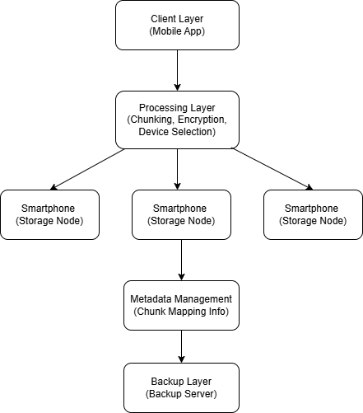

Fig. 1. System Flow of Proposed Decentralized Storage System

Architecture
The architecture of the proposed system is divided into five layers that work together to store data safely and efficiently on mobile devices in Fig. 1. The first layer is the client layer, which acts as an interface through which users interact with the system. This handles user authentication, file uploads and downloads, and communicates with the backend. The user interface is an app that people use. The processing layer manages operations such as file segmentation, encryption and device selection [6], [12]. The storage layer consists of distributed mobile devices. Each device stores encrypted data chunks in its memory and continuously shares its health status [3], [4]. The metadata layer stores information such as chunk identifiers, storage locations, and redundancy mappings [3]. This layer is very beneficial in data retrieval if some nodes are unavailable. To make the system more reliable, a backup layer is available that stores data copies in a stable environment [7]. This acts as a safeguard for our system. These layers execute sequentially, where user requests pass from the client layer to the processing layer, and then to storage and metadata layers for execution and tracking.

System Components
Client Layer acts as an interface between the user and the system and allows users to upload and download files, perform basic authentication, and transfer user requests to the backend for processing. Processing Layer handles core file operations such as file segmentation, encryption, and selection of storage devices [6], [12]. It ensures that data is fully prepared and distributed efficiently. Storage Layer consists of distributed mobile devices that store encrypted data chunks of a file. Each device contributes storage space and shares its current health status, such as battery level and storage availability [3], [4]. Metadata Layer maintains information about file chunks, their locations, and redundancy mappings [3]. It enables fast and accurate data retrieval without storing the actual data centrally. Backup Layer ensures reliability by storing copies of important data in a stable storage environment [7], [8]. It ensures data recovery in case of multiple node failures.

Methodology
The proposed system will employ a structured approach to enable effective and secure decentralised storage.
System Initialization and Device Registration: Initially, the backend system initialized modules such as encryption, device monitoring, and metadata management. Mobile nodes register with the system and continuously share their health status, such as battery level, storage availability, and network conditions. Only healthy nodes are selected for participation based on predefined criteria [4], [12].
File upload Process: This phase allows users to upload files through the mobile application. The request gets sent to the backend server for processing, and a unique file ID is generated.

Algorithm 1: File Upload Process
Input: File F, chunk size k
Output: Distributed encrypted chunks across storage nodes
1. Generate a unique file identifier (file_id)
2. Divide file F into chunks of size k → {c1, c2, ..., cn}
3. for each chunk ci do
a. Compute hash hi for integrity verification
b. Encrypt ci using AES → ei
end for
4. Select suitable storage nodes S using device selection criteria
5. for each encrypted chunk ei do
a. Store ei on selected node(s)
b. Create replicas for redundancy
c. Update metadata server with:
(file_id, chunk_index, node_location, hash)
end for
6. return success status

Chunking and Encryption: In this phase, the uploaded file is divided into smaller chunks. Each chunk is assigned a unique index and a hash value to verify integrity. These chunks are then encrypted using AES encryption to ensure confidentiality before distribution [6].

Algorithm 2: File Chunking and Encryption
Input: File F, chunk size k
Output: Encrypted chunks C
1. Divide file F into chunks of size k
2. for each chunk ci do
3. generate a hash hi for integrity
4. Encrypt CI using AES
5. store encrypted chunk
6. end for
7. return set of encrypted chunks C

Device Selection: In this phase, the system selects suitable mobile devices based on their health conditions, such as battery percentage, storage availability, and network stability. Devices that do not meet the required criteria are not selected for storage [4], [12].

Algorithm 3: Device Selection
Input: Set of available devices D
Output: Selected devices S

1. Initialize S ← ∅
2. for each device d ∈ D do
3. if d.battery ≥ threshold_battery AND
4. d.storage ≥ required_storage AND
5. d.network is stable then
6. S ← S ∪ {d}
7. end if
8. end for
9. return S

Data Distribution: In this phase, encrypted data chunks are distributed across multiple selected mobile devices. Each chunk is stored on multiple devices to ensure redundancy. The metadata server keeps track of chunk locations, replica details, and associated identifiers for efficient tracking [3], [7].

Algorithm 4: Data Distribution with Redundancy
Input: Set of encrypted chunks C, set of selected devices D, replication factor r
Output: Distributed chunks with metadata entries

1. for each chunk ci ∈ C do
2. selected_nodes ← choose r devices from D
3. for each device d ∈ selected_nodes do
4. store ci on device d
5. update metadata server
6. end for
7. end for
8. return success
Redundancy Management and Monitoring: In this phase, the proposed system continuously monitors device availability and data integrity. If a device becomes unavailable or a data chunk becomes unavailable, new replicas are automatically created on other healthy devices. This ensures continuous data availability and fault tolerance [7], [8].

Algorithm 5: Redundancy Management
Input: Stored chunks C, device status
Output: Updated replicas

1. for each chunk ci do
2. if replica count < required replicas OR device fails then
3. select new healthy device
4. create new replica of ci
5. end if
6. end for

Data Retrieval and Reconstruction: When a user requests a file, the system searches for the chunk location in the metadata server. Then the required chunks are fetched from devices where chunks are stored, and the integrity of chunks is verified using hash values. Then chunks are decrypted and in the correct order to reconstruct the original file [3], [6].

Algorithm 6: File Reconstruction
Input: Set of encrypted chunks C
Output: Reconstructed file F

1. for each chunk ci ∈ C do
2. verify integrity using hash
3. decrypt ci
4. end for
5. merge all chunks in correct order
6. return reconstructed file F

Failover and Backup Recovery: The proposed system contains a failover method to handle the situation of device failure. If chunks are missing, they are recovered from replicas or retrieved from the backup server based on the missing level and later redistributed when devices reconnect. This ensures data availability and reliability [7], [11].

Algorithm 7: Failover and Backup Recovery
Input: metadata M, device status D, replication factor r
Output: Restored chunk availability

1. for each chunk ci in metadata M do
2. available_nodes ← devices storing ci that are active
3. if count(available_nodes) < r then
4. if replicas exist then
5. select healthy device d_new
6. replicate ci from available_nodes to d_new
7. update metadata M
8. else
9. retrieve ci from backup server
10. store ci on selected healthy devices
11. update metadata M
12. end if
13. end if
14. end for
15. return system consistency maintained

Incentive Mechanism: The proposed system gives incentives to devices based on factors such as storage usage and frequency of data access. This helps in making profit for both lender and renter [5], [10].

Algorithm 8: Incentive Calculation
Input: Set of devices D
Output: Reward score for each device

1. for each device d ∈ D do
2. storage_score ← amount of storage contributed by d
3. access_score ← frequency of data access handled by d
4. reward(d) ← α * storage_score + β * access_score
5. update reward balance for device d
6. end for
7. return reward distribution

Results and Discussion

System Overview
The decentralized storage system aims to provide seamless storage services by using smartphones as storage nodes [3], [8]. It processes the data files, divides them into chunks, and distributes them across multiple nodes. It aims to achieve high data availability by performing multiple integrity and security checks on nodes during retrieval operations. The architecture ensures smooth connectivity between backend, metadata servers, and storage nodes. Additionally, it also provides an incentive model for encouraging user participation [5], [10].

System Behaviour
The system will continuously perform automated operations to ensure efficient data upload and retrieval. During data upload, data files will be divided into chunks, and each chunk will be encrypted with the AES encryption technique, and distributed to the best suitable nodes based on the storage level, battery level and network conditions [4], [6], [12]. During data retrieval, the system will check for data integrity, confidentiality, and reassemble the chunks into the original data. If the data part is found as encrypted or missing, it will retrieve the data from alternative replicas, or from the emergency backup if all the available nodes fail [7], [8].

Performance Evaluation
To better evaluate the proposed system performance, simulation-based evaluation was conducted using key parameters such as file upload time, file download time, encryption speed, decryption speed, and data availability.
Table 1: Simulation Results

Number of Nodes | Upload Time (ms) | Download Time (ms) | Data Availability (%)
5 | 1200 | 900 | 95
8 | 1350 | 1000 | 96
10 | 1500 | 1100 | 97
12 | 1700 | 1250 | 97.5
15 | 2000 | 1400 | 98
18 | 2150 | 1500 | 98.5
20 | 2300 | 1600 | 99

As shown in Table 1 and Fig. 2, the upload time increases with the number of nodes due to coordination overhead.
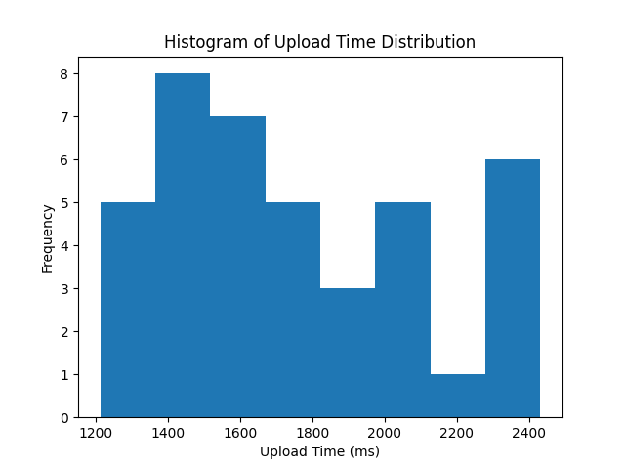

Fig. 2. File Upload Time Analysis

From Table 1 and Fig. 3, it can be observed that download time is lower than upload time but increases gradually with system size.
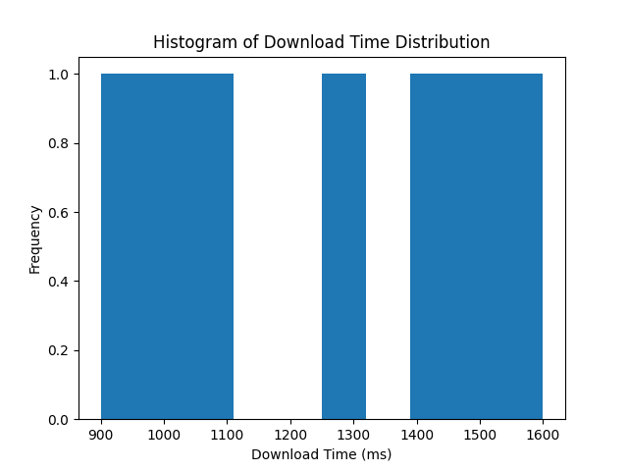

Fig. 3. File Download Time Analysis

According to Table 1 and Fig 4, data availability improves significantly with increasing nodes due to redundancy.
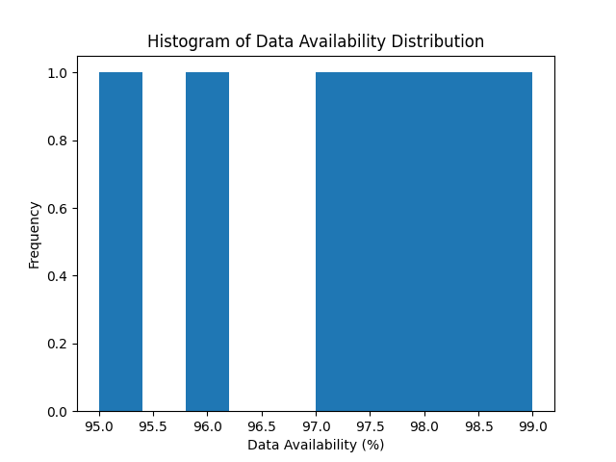

Fig. 4. Data Availability Distribution

As illustrated in Fig. 5, the encryption overhead stays consistent across different file sizes. The optimized decentralized system performs better with a lower overhead of 15%, compared to 20% in enterprise decentralized systems and 18% in centralized cloud systems, showing improved efficiency.
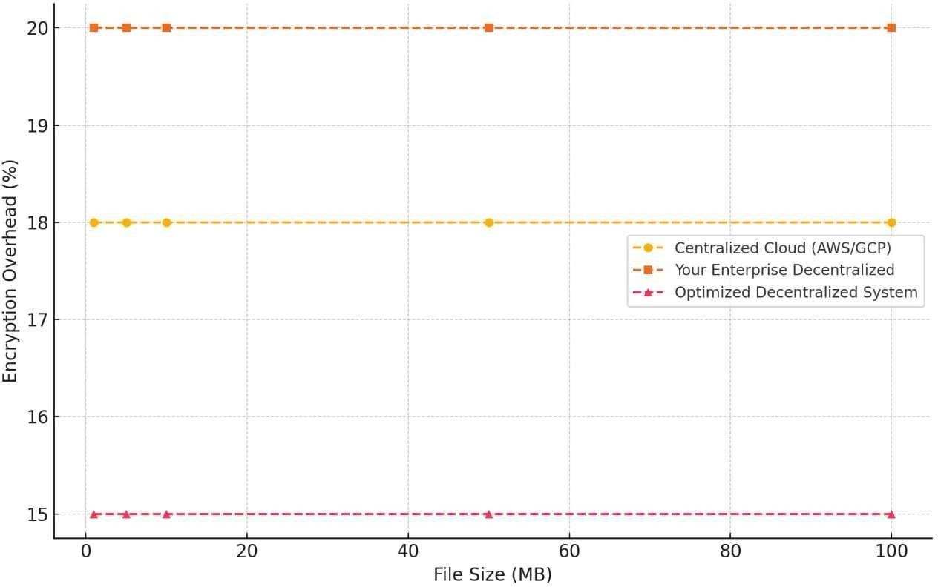

Fig. 5. Encryption Overhead

As shown in Fig. 6, decryption time increases as the file size grows in all systems. However, the optimized decentralized system performs better than the enterprise decentralized approach and delivers performance similar to centralized systems.
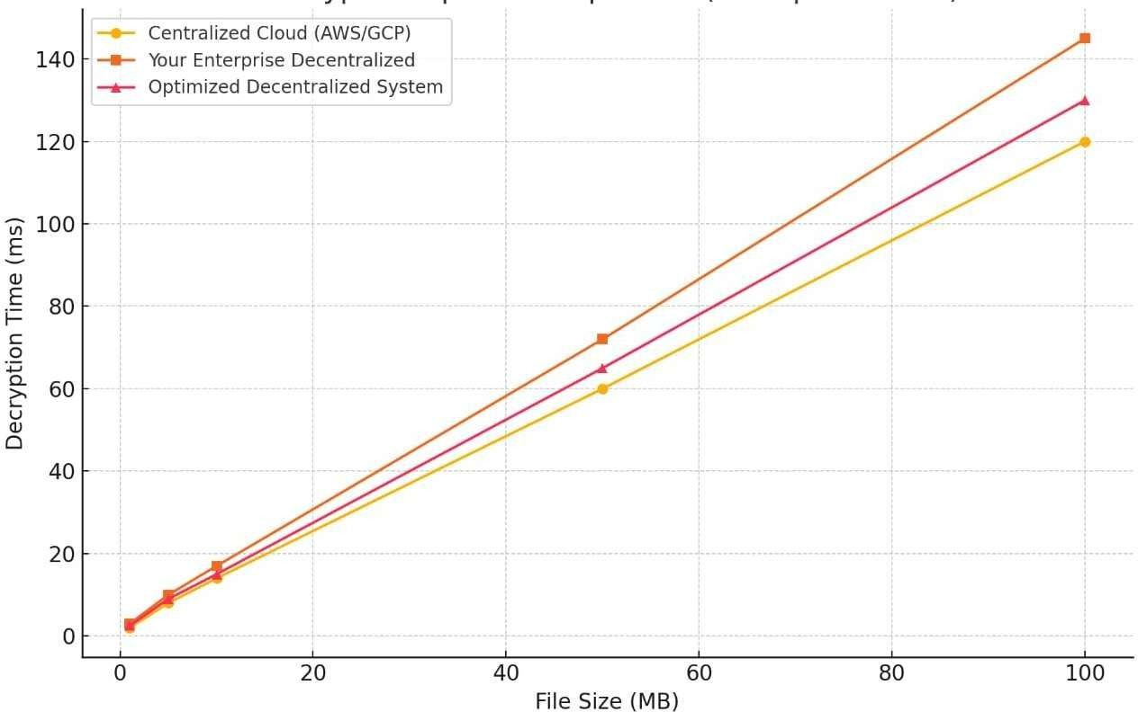

Fig. 6. Decryption Overhead

The cost analysis shown in Fig. 7 indicates that decentralized storage models are more affordable than centralized cloud platforms. Methods like erasure coding help lower storage costs even further while still keeping the system reliable.
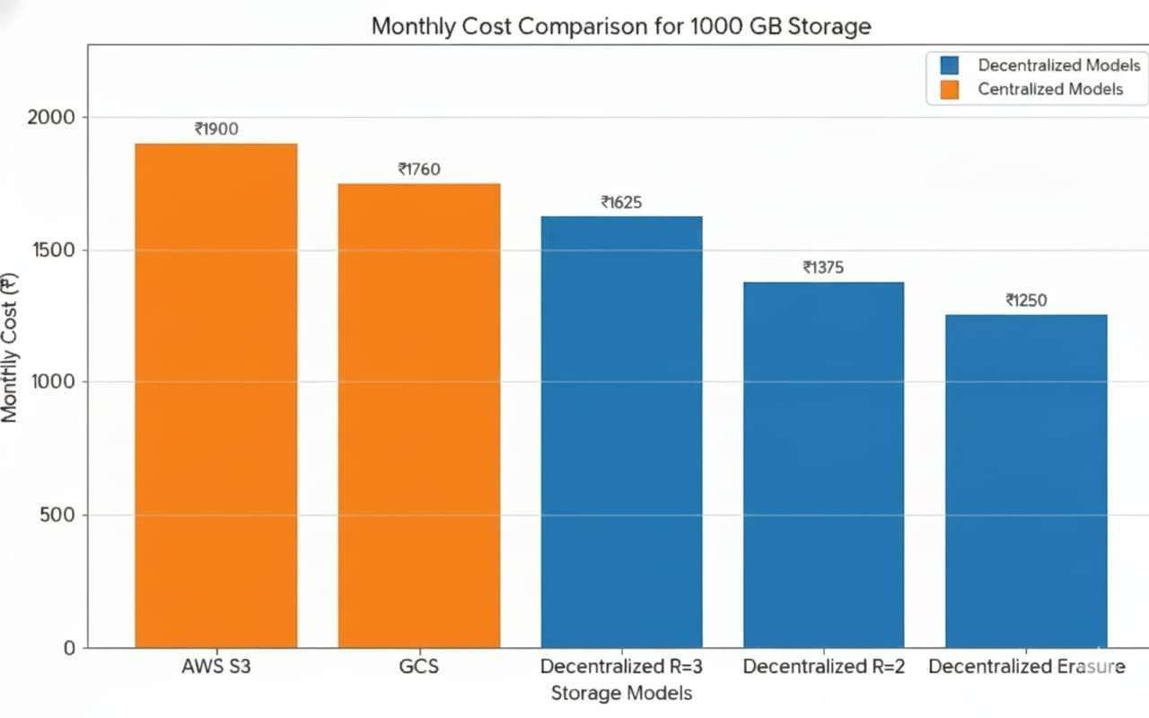

Fig. 7. Cost Analysis

As illustrated in Fig. 8, he proposed system offers better security because it uses encryption and distributed storage, which helps reduce the risks linked to centralized data breaches.
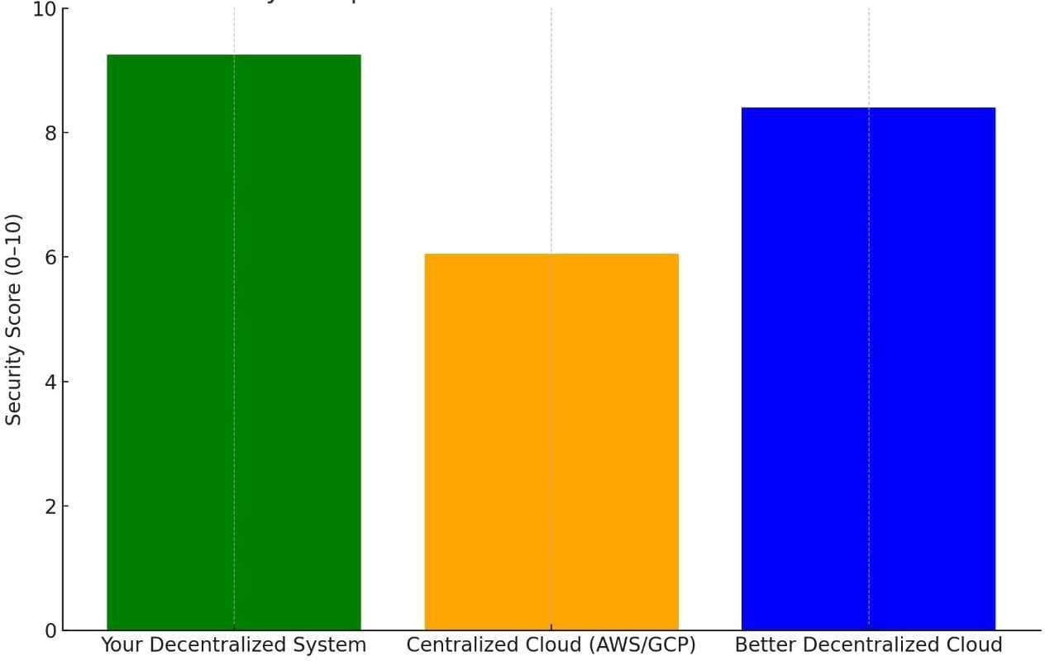

Fig. 8. Security Analysis

As shown in Fig. 9, device health metrics are used to decide how suitable a node is for storage. Nodes with better battery levels, available storage, and network performance help improve the overall reliability of the system.
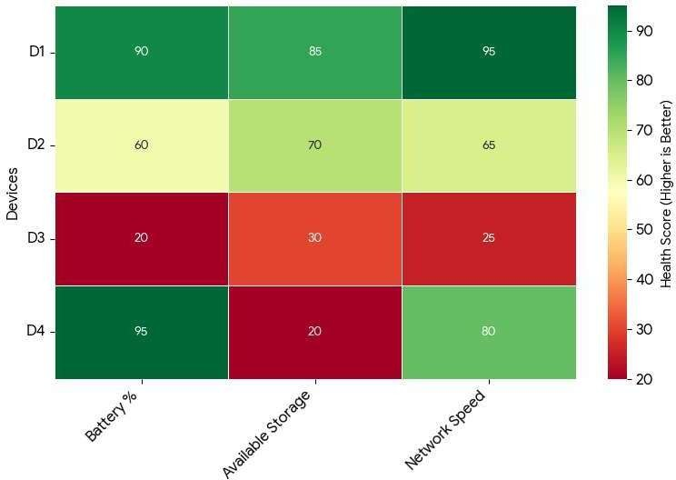

Fig. 9. Device Health Scoring Analysis

Discussion
The main idea of the system is to use smartphones as storage nodes, which could possibly increase the flexibility of the system to fulfil user demands. Further, chunking the data files, storing multiple copies, and having an emergency backup for the worst case, makes the system secure, highly available and fault-tolerant [7]. The health-based device selection also increases the performance of nodes. An incentive-based model is another noticeable point to motivate users to use their vacant storage in return [5].

Comparative Analysis
Parameter | Centralized Cloud Storage | CDN-Based Storage | Proposed Decentralized Storage System
Data Availability | Moderate availability dependent on server uptime | Improved availability through distributed caching | Very high availability (95–99%) due to multi-node replication [7], [8]
Upload Performance | Limited by server bandwidth and infrastructure | Slight improvement due to distributed servers | Faster upload due to parallel chunk distribution across multiple nodes [2], [3]
Download Performance | Higher latency due to centralized access | Faster than centralized but limited by CDN nodes | Lowest latency with parallel chunk retrieval from multiple devices [2], [8]
Fault Tolerance | Limited; server failure may cause service interruption | Moderate fault tolerance | High fault tolerance with replica-based recovery [7], [11]
Scalability | Requires infrastructure expansion | Scalable but costly | Highly scalable as storage increases with participating devices [1], [2]
Storage Cost | High operational cost (e.g., AWS S3, GCS) | Moderate cost | Lower cost due to the utilization of unused device storage [5], [8]
Security | Data stored in centralized servers; risk of large-scale breach | Moderate security with distributed nodes | Strong security with AES encryption and distributed chunk storage [6], [9]
Single Point of Failure | Possible | Reduced but still infrastructure dependent | Eliminated due to decentralized architecture [1], [10]

Conclusion And Future Work
Instead of relying on expensive centralized data servers, the project presents a secure, scalable, and cost-effective method to use mobile devices as storage nodes. It offers security, availability, confidentiality, and reliability in case of node failure with the help of file chunking, AES encryption, redundancy, and health-based device selection. The fair model inspires users to use their unused space and get paid in return [10]. It creates a sustainable environment for the users to rent and lend data. The emergency backup recovery system makes the architecture highly fault-tolerant [7], [11c]. With continued development, the system has a high potential to replace the conventional data center and become a cost-effective, secure and reliable option in future. For future work, there could be an automated AI-driven system to split the data into chunks [12]. Real-time health monitoring of the storage node will increase the system's performance and reliability on the nodes. Advanced encryption techniques like zero-knowledge encryption could increase the security and confidentiality. Storage replication could be replaced by erasure coding to optimize storage space [8]. With these increased integrations, the architecture can evolve into a global, low-cost cloud alternative that provides security, confidentiality, data availability, and scalability for digital appliances.

References

- Protocol Labs, “Filecoin: A Decentralised Storage Network,” Protocol Labs Research Report, 2020.
- J. Benet and D. Greco, “IPFS: Content-Addressed, Peer-to-Peer File System for Decentralised Applications,” Protocol Labs Technical Whitepaper, 2020.
- Y. Wang, H. Chen, and Z. Li, “A Hybrid Mobile-Edge Storage Model for Distributed Data Fragmentation,” IEEE Transactions on Mobile Computing, vol. 20, no. 5, pp. 1882–1895, 2021.
- L. Zhang and R. Kumar, “Energy-Aware Peer Storage Using Mobile Devices in Edge Environments,” IEEE Access, vol. 9, pp. 112040–112053, 2021.
- A. Jangid and R. Patel, “Incentive-Based Storage Networks Using Dynamic Credit- Reward Mechanisms,” Journal of Network and Computer Applications, vol. 197, pp. 103289, 2022.
- S. Park and P. Thapa, “Authenticated Chunk Encryption and Multi-Replica Storage for Secure Distributed Systems,” IEEE Communications Letters, vol. 26, no. 3, pp. 611–615, 2022.
- M. Hernandez, T. Alvarez, and G. Prieto, “Redundancy-Optimised Replication for Mobile Cloud Storage,” Future Generation Computer Systems, vol. 144, pp. 327–339, 2023.
- S. Raman and A. Bose, “Distributed Storage Using Smartphone Clusters with Erasure Coding,” IEEE Transactions on Cloud Computing, vol. 11, no. 2, pp. 499–512, 2023.
- K. Sato and H. Lin, “Secure Distributed Chunk Encryption Using GCM Nonce Rotation for Edge Storage,” IEEE Internet of Things Journal, vol. 11, no. 1, pp. 845– 857, 2024.
- A. Al-Harbi and S. Singh, “Blockchain-Based Incentive Marketplace for Decentralised Edge Storage Networks,” IEEE Transactions on Services Computing, vol. 17, no. 4, pp. 912–925, 2024.
- T. Kwan and M. Priyadarshi, “Self-Healing Storage Grids for Mobile Device Networks,” ACM Journal on Autonomous and Adaptive Systems, vol. 20, no. 2, pp. 1– 15, 2025.
- R. Ortega and F. Malik, “AI-Driven Dynamic Chunk Placement with Device Reliability Scoring,” IEEE Transactions on Emerging Topics in Computing, vol. 13, no. 2, pp. 278– 290, 2025.

